
Middlefield Community Primary School
Behaviour Policy

Aims:
This behaviour policy is designed to promote and facilitate our school values through the Middlefield Way:
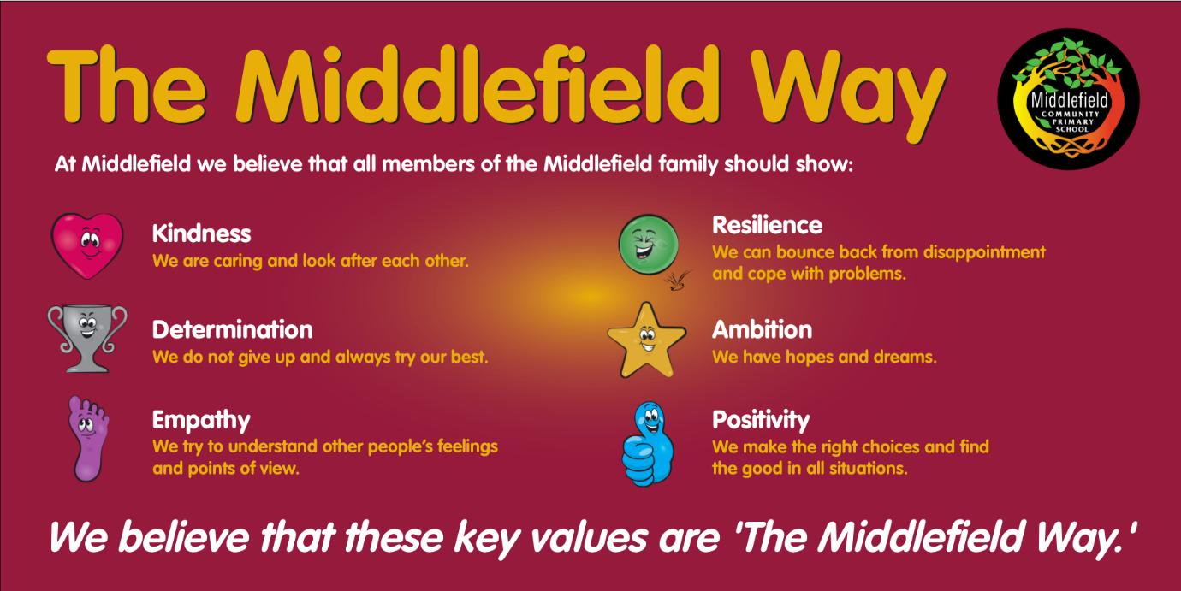

Behaviour expectations:
To show the Middlefield Way…
1. We speak using a calm voice.
2. We help each other to be safe.
3. We help each other to learn.
4. We respect each other and our environment.
5. We follow instructions.

Classroom sanctions
If you choose not to follow our expectations these consequences will happen every time …
1. A member of staff will tell you to stop, they will tell you once, and they will not engage in conversation or stop the lesson to repeat the warning.
2. Your name will be written on the board, once again teachers will not stop the lesson or repeat warnings. The lesson must continue as uninterrupted as possible.
3. A tick will be put next to your name and you will receive a negative behaviour point.
4. If you continue this behaviour, further ticks, and therefore negative points will be added.
5. Two ticks in the same session (AM/PM) means you will lose part of your lunch break in Reflection Club, where you will complete a reflective activity.
6. Your parents/carers will be alerted via Class Charts when you receive negative behaviour points. Persistent patterns of negative behaviour may result in appropriate intervention and parents/carers being called.

Negative behaviour on the playground will result in a negative behaviour point and appropriate conflict resolution by members of staff on duty.

Rewards
Children will be rewarded with positive behaviour points (on Class Charts) linked to our Middlefield Way values. Points can be redeemed on Class Charts’ online store. Children will be able to purchase small, instant prizes or can save up for larger prize rewards. Consistent positive behaviour will also be celebrated via notifications/badges.

Serious Incidents
Sometimes an incident happens which overrides the above. This will be an incident of serious misbehaviour…
• Aggressive or violent behaviour towards pupils and or staff
• Incidents of a sexual nature
• Incidents which are deemed to put others safety at risk
• Bullying, racist, sexist or homophobic comments
For these incidents the HT or DHT should be informed immediately. These incidents will be recorded on CPOMS. Parents will be informed as soon as possible. 5 negative behaviour points will be applied for each incident.

When some help is needed
We acknowledge that some children may have particular emotional, social, medical or learning problems which may mean that they will sometimes display challenging behaviour. In these cases we will aim to work with child, parent / carer and professionals to find out what the problem is, try to understand it and put together a plan with targets to address the additional need/s. This will be done by the SLT and class teacher and parents / carers will, whenever possible, part of the process. We will always try to ensure parents / carers are fully informed. We also realise that, in spite of the support and help offered in school, sometimes we need to ask for outside agencies to become involved, like the Educational Psychology service or health.
Exclusions
The Governing Body of Middlefield School will follow the Department for Education and Local Authority guidelines.
In this school exclusion is always used as a last resort, after all other strategies have failed. It is applied in cases where, by allowing a child to remain in school, we would be placing other pupils /staff at risk or by allowing a child to remain in school it would be detrimental to the education or welfare of other pupils/ staff.
Whilst a pupil is excluded they are not allowed onto school premises.
The head teacher, or senior leader, will contact the parent as soon as possible. A letter will be sent home, setting out the reason why the exclusion has taken place and the school will inform the Local Authority.
Please see ‘School Exclusions: Advice to Parents’ for further information
Bullying
• Deliberately hurtful behaviour
• It is repeated over a period of time
• It is difficult for those who are being bullied to defend themselves
We endeavour to prevent bullying by implementing this policy consistently throughout the school. Bullying will always be taken seriously and dealt with immediately.
Bullying is the wilful and repeated desire to hurt, threaten or frighten someone. ‘Falling out’ with a friend is not bullying.
A bully has to have some kind of power over the victim and use it in an abusive and unkind way over a period of time. An argument between two equal partners is not bullying.
All confirmed incidents of bullying will be recorded and monitored; parents will be informed.
Please see school’s ‘Anti-bullying policy’ for further information.
Racial harassment
School will also act when physical, verbal or psychological abuse is used because of differences in race, colour or religion. We encourage everyone to respect others and their beliefs.
Details of racist incidents are kept by the head teacher in a log and parents will be informed of incidents of racial harassment.
Homophobic harassment
School will also act when physical, verbal or psychological abuse is used because of differences in sexual orientation.
It can include spreading rumours that someone is ‘gay’ or using terms such as ‘gay boy’. Even when pupils may not be aware what the words mean it is still name calling and cannot be considered ‘harmless banter’. Pupils need to understand that this is not acceptable.
Governors are kept fully informed of incidents around bullying and homophobic and racial abuse

The use of Reasonable Force
Guidance from the DfE states…
• The term reasonable force covers the broad range of actions used by most teachers at some point in their career that involves a degree of physical contact with pupils
• Force is usually used to control or restrain. This can range from guiding a pupil by the arm to more extreme circumstances such as breaking up a fight or when a student needs to be restrained to prevent violence or injury
• Control means either passive physical contact, such as standing between pupils or blocking a pupil’s path. Restraint means physically holding back. This is typically used in more extreme circumstances i.e. when pupils are fighting
• ‘Reasonable’ means using no more force than necessary
• Staff must always try to avoid acting in a way that might cause injury, but in extreme cases it may not always be possible
• Staff should avoid physical contact when dealing with incidents where possible
We will always tell parents immediately if force has been used in an incident
The staff to which this power applies…
1. A teacher who is working at our school
2. Any other person the HT has authorised for example; Support staff, dinner staff

