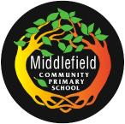
Parent Code of Conduct
Middlefield Community Primary School

We believe that the Middlefield Way should be adopted by all members of our school community:
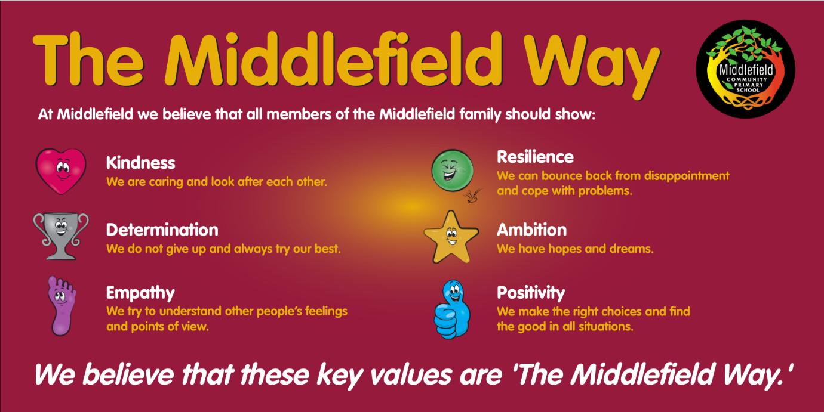

Purpose and scope
At Middlefield, we believe it’s important to:
- Work in partnership with parents to support their child’s learning
- Create a safe, respectful and inclusive environment for pupils, staff and parents
- Model appropriate behaviour for our pupils at all times

To help us do this, we set clear expectations and guidelines on behaviour for all members of our community. This includes staff (through the staff code of conduct) and pupils (through our behaviour policy).
This code of conduct aims to help the school work together with parents by setting guidelines on appropriate behaviour.
We use the term ‘parents’ to refer to:
- Anyone with parental responsibility for a pupil
- Anyone caring for a child (such as grandparents or child-minders)

Our expectations of parents and carers
We expect parents, carers and other visitors to:
- Respect the ethos, vision and values of our school
- Work together with staff in the best interests of our pupils
- Treat all members of the school community with respect – setting a good example with speech and behaviour
- Seek a peaceful solution to all issues
- Correct their own child’s behaviour (or those in their care), particularly in public, where it could lead to conflict, aggression or unsafe conduct
- Approach the appropriate member of school staff to help resolve any issues of concern
- Have an open mind and be prepared to listen to the perspective of others – you may have only heard one side of a story.

Behaviour that will not be tolerated
- Disrupting, or threatening to disrupt, school operations (including events on the school grounds and sports team matches)
- Swearing, or using offensive language
- Displaying a temper, or shouting at members of staff, pupils or other parents
- Threatening another member of the school community
- Sending abusive messages to another member of the school community, including via Class Charts, text, email or social media
- Posting defamatory, offensive or derogatory comments about the school, its staff or any member of its community, on social media platforms
- Making allegations which turn out to be vexatious or malicious
- Use of physical punishment against your child while on school premises
- Any aggressive behaviour (including verbally or in writing) towards another child or adult
- Disciplining another person’s child – please bring any behaviour incidents to a member of staff’s attention
- Smoking, vaping or drinking (or being under the influence of) alcohol on the school premises (unless alcohol has been allowed at a specific event)
- Possessing, taking or being under the influence of drugs (including legal highs)
- Bringing dogs onto the school premises (other than assistance dogs)

Breaching the code of conduct
If the school suspects, or becomes aware, that a parent has breached the code of conduct, the school will gather information from those involved and contact the parent about the incident.
Depending on the nature of the incident, the school may then:
- Send a warning letter/message to the parent
- Invite the parent into school to meet with a senior member of staff or the headteacher
- Contact the appropriate authorities (in cases of criminal behaviour)
- Seek advice from Liverpool City Council regarding further action (in cases of conduct that may be libellous or slanderous)
- Ban the parent from the school site
- Block the parent from selected forms of communication with the school
The school will always respond to an incident in a proportional way. The final decision for how to respond to breaches of the code of conduct rests with the headteacher.
The headteacher will inform the chair of governors after banning a parent from the school site.

