

Middlefield Community Primary School
SEF
September 2025
Social Context:
Middlefield Community Primary School is located in an area of acute social and economic deprivation and disadvantage; it is ranked 1 on the Indices of Multiple Deprivation for England. ASP data had a School Deprivation Indicator of 0.45 for Middlefield compared to the national average of only 0.21. Speke is ranked one for deprivation on the National Statistics data base. Our postcode provides an IDACI decile of 1. Area profile statistics show high rates of both long and short term unemployment, ill health and high levels of crime. Statistics also show very low rates of higher education and skills based employment, with only 5% of the adult population defined as being in a 'Higher Social Class Household'. 85.4% of the ward fell into the most deprived 10% nationally. Of this total, 14.2% actually fell into the most deprived 1% nationally.
School has well above the average number of pupils eligible for Pupil Premium at approximately 70%. We also have 13% EAL students. The overwhelming majority of our community do not attend organised religious worship of any denomination.
16% of students are on the SEN register. Mobility can be an issue. School has 6 official CLA pupils and 4 post-CLA.
In the Summer Term 2025, 9 children were supported by an EHAT, 7 had CP plans, 2 had CIN plans. Including initial assessments and schools own monitoring and concern lists, there are a total of 104 children- 32% of the school population (R-Y6)- receiving support. We have many children who have extremely difficult home circumstances. Crime is a serious problem, including drug related incidents. Domestic violence has impacted many of our children. Children are very well supported by the Safeguarding Team, including the Deputy Head Teacher (DSL), two full-time Learning Mentors and the Head Teacher. School has a considerable pastoral offer to support our children and families. School also works very closely with outside agencies including social care, child mental health, social inclusion and health. School does also effectively challenge and hold agencies to account through established escalation procedures in order to be powerful advocates for pupils and families.
Overall Judgement- Good
‘Safeguarding is effective’ Ofsted, March 2024
The Quality of Education is Good
Children's Behaviour and Attitudes are Outstanding, as is their Personal Development
Attendance remains the key school improvement priority, though there have been strong and consistent improvements in attendance and persistent absence in the last three years. School is highly ambitious to surpass local and national averages.
Early Years Provision is Good
Leadership and Management are highly effective

Quality of Education Judgement- Good
‘The school has high expectations for pupils’ academic achievement. Pupils try their best and work hard. Pupils learn about the world of work and money. This enables them to have clear goals and aspirations for life beyond Middlefield. Pupils enjoy learning new information and are enthused when sharing this knowledge with others. Pupils spoke confidently about their recent learning. Typically, pupils achieve well. The school has deliberately built in a series of rich experiences for pupils, such as trips to the local safari park or to museums and art galleries. These events spark pupils’ interests in their learning and opens further opportunities for them to learn beyond the local area.’ Ofsted, March 2024
Leaders have designed a curriculum that is ambitious. It is designed to give all pupils, including disadvantaged and SEND, the knowledge and cultural capital they need to succeed in life. At Middlefield, we follow the graduated approach and are committed to offering early intervention to prevent further gaps or behaviour needs deteriorating. We work closely with outside agencies, such as SENISS, Educational Psychologist and OSSME who offer high quality advice and recommendations. Pupils who are on SEND support may have an adapted curriculum, if it is recommended by an outside agency. SEND pupils, who are working significantly below, are assessed with GL assessments. Then a personalised, challenging curriculum is designed to meet their complex learning needs to ensure a good level of progress. This personalised curriculum includes reading, writing, speech, communication and maths. For pupils who are in years 5 and 6, a humanities and science curriculum are also created.
At Middlefield, we believe that knowledge and skill are intertwined and our curriculum focuses on ensuring that pupils can achieve both. Through this development of knowledge and skills, we ensure progression and depth of learning. Our spiral curriculum is built around the aims and objectives set out in the national curriculum. Learning is reviewed across topics, year groups and key stages to embed knowledge into children’s long-term memory. This learning is contextualised to suit our children and community, making learning meaningful and relevant. Pupils study the full curriculum; it is not narrowed and has many additional areas of enrichment. The school provides rich opportunities for pupils to gain a wider understanding and appreciation of the world. Pupils develop detailed knowledge and skills across the curriculum and, as a result, achieve well.
Subject Leaders are responsible for the organisation of subject specific vocabulary in their curriculum area. Key vocabulary specific to each unit is included in all planning. Retrieval vocabulary from related prior units is also highlighted. All vocabulary is introduced, built upon, recalled and reviewed in every lesson, ensuring a vocabulary rich curriculum. Through a range of monitoring activities, the leadership team have a clear understanding of the areas of the curriculum which need development. Leaders are confident that any issues are addressed in a realistic timescale.
A progressive approach to the reading curriculum develops pupils’ fluency, confidence and enjoyment in reading. A ‘Whole Class Reading’ approach is used, where sessions are built around the teacher reading high-quality and challenging texts, which are dissected by the class through high-level questioning and discussion. Teachers follow the Middlefield Reading Spine that contains set texts for each year group. These chosen texts include essential reads, traditional tales, classic and contemporary books alongside books about diversity. This wide variety of books promotes a love of reading and covers a depth of challenging vocabulary.
School follows a schematic approach to the teaching of phonics through the use of Anima Phonics. This ensures consistency throughout EYFS and KS1 as well as improved attainment. Accompanying fully decodable books are also used to support children’s learning.
Teachers promote a love for maths via a mastery approach, using concrete, pictorial and abstract concepts and procedures to deepen pupils’ understanding of mathematics (using White Rose scheme). Pupils are also encouraged to reason and solve a variety of problems, enabling life skills and resilience through maths.
Areas for Improvement In a few curriculum subjects, the assessment strategies that the school uses are in the early stages of implementation. This means that teachers’ checks on what pupils know are not as effective as they could be. The school should refine its methods for checking what pupils remember over time, to ensure that any gaps in learning are identified and addressed. In a few subjects, the school does not provide enough opportunities for pupils to revisit the essential knowledge, skills and vocabulary that they learn. On occasion, this prevents some pupils from having sufficiently secure foundations on which to build new learning. In these remaining curriculum areas, the school should develop strategies to ensure that pupils embed knowledge successfully into their long-term memory.’ Ofsted, March 2024

Behaviour and Attitudes: Judgement- Outstanding
‘Pupils are happy and enjoy coming to this welcoming school. Their positive behaviour helps to create a calm and orderly learning environment. The ‘Middlefield Way’ is threaded through everything that pupils and staff do. Pupils behave well and demonstrate the school values of ambition, resilience, empathy, determination, kindness and positivity. It is important to them that everyone is treated fairly’ Ofsted, March 2024
We have extremely high expectations for pupils’ behaviour and conduct. These expectations are commonly understood and applied consistently and fairly through a shared behaviour policy, attractive reward system and fair and equitable sanctions and consequences. This is reflected in pupils’ positive behaviour and conduct. Pupils behave consistently well, demonstrating high levels of self-control and consistently positive attitudes to their education. If pupils struggle with this, the school takes intelligent, fair and highly effective action to support them to succeed in their education. This may include support from the SENCO or from our extensive pastoral provision. Leaders support all staff well in managing pupil behaviour. Staff make sure that pupils follow appropriate routines. Pupils’ attitudes to their education are positive. They are committed to their learning, know how to study effectively and do so, are resilient to setbacks and take pride in their achievements. Relationships amongst pupils and staff reflect a positive and respectful culture. Pupils are safe and they feel safe.
Our 'Middlefield Way' values are central to the culture of our school:
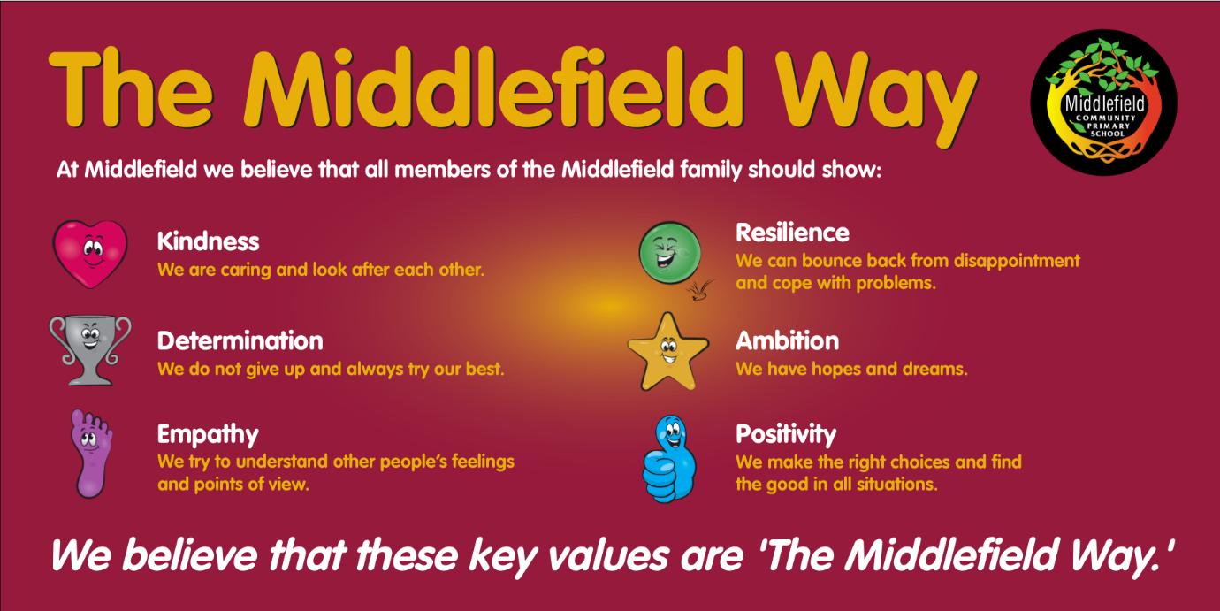
Pupils value their education. Attendance and punctuality has improved significantly over the past three years. It is still a barrier for some children and remains a key school improvement priority. School consistently takes appropriate, swift and effective action to combat low-attendance and this approach has resulted in year on year gains.
Leaders, staff and pupils create a positive environment in which bullying is not tolerated. If bullying, aggression, discrimination and derogatory language occur, they are dealt with quickly and effectively and are not allowed to spread. This is documented through comprehensive logs on CPOMS, detailing allegations, investigations and consequences.
Where pupils struggle with the structure and rules, the school takes intelligent, fair and highly effective action to support them to succeed in their education. Suspensions and internal exclusions are used appropriately and only as the final steps of a transparent process. The school reintegrates excluded pupils on their return and manages their behaviour effectively. Permanent exclusions are used appropriately as a last resort. As a sign of the success of our systems and culture, the number of days of suspensions are low and there have been no permanent exclusions for over a decade.

Personal Development Judgement- Outstanding
‘The school has a well-thought-out programme for pupils’ personal development. Pupils learn about well-being and maintaining a healthy lifestyle. They spoke with passion about how the school supports their mental health. Pupils talked confidently about a range of strategies that they can use. They know that they can speak to someone if they have any worries.’ Ofsted March 2024
Pupils’ spiritual, moral, social and cultural development and, within this, the promotion of fundamental British values, are at the heart of the school’s work. Pupils demonstrate high levels of mutual respect and tolerance and are sensitive to the needs and views of others. This culture has been brought about through a focus upon correct attitudes and is evidenced through children's outstanding behaviour.
School leaders provide good information and respond appropriately to concerns. Leaders protect pupils from radicalisation and extremism. Staff are trained and vigilant, confident and competent to encourage open discussion with pupils. There is a planned cycle of staff CPD and Safeguarding training, as well as a rolling programme of events, visitors and special assemblies to promote safety and positive life choices.
Our Pastoral Pyramid:
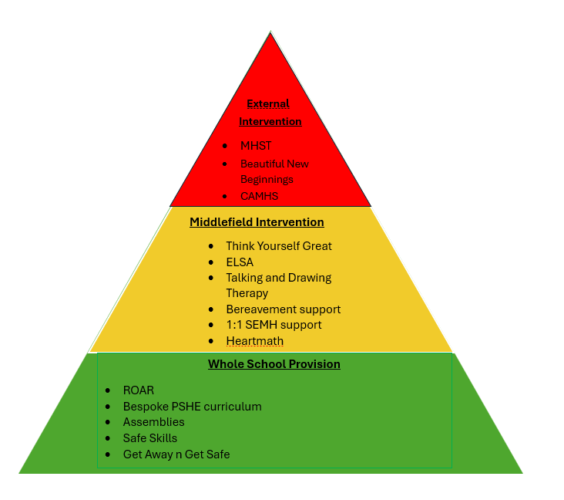
The pastoral team deliver the 'Roar' response to mental health to all children in Y1 to Y6. Themes covered include: Resilience; Feelings and Emotions; Worry and Anxiety; Relaxation.
Our Pastoral support is extensive and reaches huge numbers of children- especially our most vulnerable. Our Pyramid of Need ensures that the correct children receive support. During the school year 24-25:

Pastoral Intervention – delivered by pastoral team
Intervention | Number of children
Think Yourself Great (Group sessions) | 46
Social and Emotional 1:1) | 35
Talking and Drawing Therapy (1:1) | 12
Heartmath (1:1) | 4
Bereavement | 1
ELSA | 19
TOTAL | 117
Pastoral Intervention– delivered by external agencies
Intervention | Number of children
Seedlings | 3
Beautiful New Beginnings | 16
MHST | 3
OSMEE | 30
TOTAL | 52
This meant that 169 children (over 50% of all children in school) benefitted from bespoke support.
Pupils enjoy learning about how to stay healthy, about emotional and mental health and about safe and positive relationships. For example, Year 5 and 6 pupils have annual support from 'Brook Advisory Centre', 'Ariel Trust' and 'Get Away 'n' Get Safe'. Beautiful New Beginnings also provide whole class intervention and support. PSHE and RSE are well embedded in the curriculum.
We provide a rich and well planned range of curricular and extra curricular opportunities to allow pupils to practice resilience, independence and grow in character. Pupils are supported to get maximum impact from these experiences. This extensive provision ensures a wide range of opportunities to nurture, develop and stretch pupils' talents and interests. These opportunities are appreciated and pupils make good use of them.

Leadership and Management Judgement- Good
Safeguarding is a key strength of the school. All documentation and record keeping is good and staff are fully aware of the signs of potential abuse and how to pass these on. The school makes use of external agencies to support children who are at risk. Recruitment policies and practices are managed to ensure that children are protected. All training is in line with KCSIE and all documentation is amended appropriately. There are clear records of staff having read at least part one of KCSIE and this can be evidenced in their practice.
Leaders and governors have an accurate and comprehensive understanding of the quality of education at the school. This helps them plan, monitor and refine actions to improve all key aspects of the school’s work. There are references to the key aspects of improvement in all aspects of the school's work.
The school's vision is ambitious, has high expectations for performance and conduct and is underpinned by a strategy for raising standards in all areas. It is communicated to key stakeholders and delivered through strong shared values, policies and practice.
School engages with stakeholders and can evidence its actions based upon feedback. The school regularly informs stakeholders of its actions and there is consultation where appropriate.
Governors have an accurate and comprehensive understanding of the quality of education at the school. This helps them plan, monitor and refine actions to improve all key aspects of the school’s work. Governors are aware of general areas of spend and impact.
Leaders engage with staff at all levels and are aware and take account of the main pressures on them. They are realistic and constructive in the way that they manage staff, including workload. Any issues of bullying and harassment of staff are dealt with.
Leaders aim and plan to give all children the best opportunity to complete their studies. The inclusive culture of the school proactively supports staff and maximises the chances of all children succeeding.
Professional development is focused upon increasing teachers' ability to teach and assess the curriculum in more effective ways. Teachers' curriculum knowledge and subject pedagogy build across the year.
Leadership development and capacity has been a priority for a number of years. Several teachers have undertaken leadership development programmes in the past 3 years. these have been carefully linked to school improvement priorities and core subjects. This has driven significant improvements in outcomes and resulted in leaders being responsible and accountable.
Leaders are fully aware of all protected characteristics. This is reflected in school policies.
‘Staff feel fully supported by the school. They spoke about an openness to listen, respond and act to any concerns or training needs that they may have. Staff are highly thankful of the work that is completed by the school to set out the learning intentions clearly for them in many subjects. They said that this has effectively supported their work-life balance and well-being. Governors understand and fulfil their statutory duties with rigour. They have the necessary skills to undertake their roles exceptionally well. They challenge and support the school so that Middlefield is a happy, safe and purposeful place to work and to learn.’ Ofsted March 2024

Early Years Judgement- Good
Children's safety and safeguarding is central to everything. Adults effectively support children's growing understanding and help them to learn to take appropriate, measured risks. They are proactive in dealing with safeguarding concerns and liaise successfully with other organisations to ensure appropriate steps are taken to promote children's welfare.
Upon entry, the majority of our children are at development levels which are considerably below age-related expectations. A significant barrier for many children can be Speech and Language. School deliver WELLCOM and NELI to address this barrier.
Leaders have developed a curriculum that is ambitious and designed to give children, particularly the most disadvantaged, the knowledge, self-belief and cultural capital they need to succeed in life. The curriculum is coherently planned and sequenced. It builds on what children know and can do, towards cumulatively sufficient knowledge and skills for their future learning.
Staff are knowledgeable about the areas of learning they teach. They manage the EYFS curriculum in relation to the learning needs of their children. The quality of teaching is consistently strong.
The school’s approach to teaching early reading and synthetic phonics is systematic and ensures that most children learn to read words and simple sentences accurately by the end of Reception with increasing speed and fluency. Children achieve and make excellent progress from their low starting point. However, overall GLD remains below Local and National averages.
Staff also take time to read to children in a way that excites and engages them, introducing new ideas, concepts and vocabulary. There is a sharp focus on ensuring that children acquire a wide vocabulary and communicate effectively.
Staff are knowledgeable about the teaching of early mathematics. They ensure that children have sufficient practice to be confident in using and understanding numbers. Reception follows the White Rose Maths scheme in line with the rest of the school.
Assessment is embedded within the daily routine with a focus on observing children’s learning through child-initiated play, alongside adult led tasks. This is then used to inform future planning appropriate to the needs of the children.
Adults have strong knowledge of typical child development and, where children's starting points are below those of other children of their age, appropriate support is quickly identified. They work collaboratively with other professionals and the SENCO to tailor support for individuals, using the Graduated Approach.
Behaviour is strong. Personal, Social and emotional development is key to all areas of Early Years, Children also have bespoke lessons through ROAR and learn about values and respect through whole school assemblies and The Middlefield Way. Children are confident to approach adults and talk to each other. They co-operate, share resources, and take turns, according to their age. They are motivated and interested in activities and take part in opportunities that promote understanding of people, families and communities. There are a wide variety of opportunities for children to learn independently and explore their ideas. As a consequence, children are beginning to manage their own feelings and behaviour, understanding how these have an impact on others. They are developing a sense of right from wrong.
School effectively supports transition, through visits, familiar routines, and as a result, children are emotionally well prepared for the next stage in their learning. Staff work hard to get to know children's individual likes and dislikes and to help children settle well. As a result, children are emotionally well prepared for the next stage in their learning.
Systems work effectively to engage parents, including those who are more reluctant to contribute. Parents are also strongly encouraged to engage in their children's learning through face to face communication at Parent meetings, stay and plays, drop off and pick up. They also share learning and communicate via the online learning journal Tapestry. This allows for timely correspondence and a positive school/home link.

