

Behaviour policy

Approved by: C Evans |  | Date: November 2026
Next review due by: | November 2027

Aims
This behaviour policy is designed to promote and facilitate our school values through the Middlefield Way:
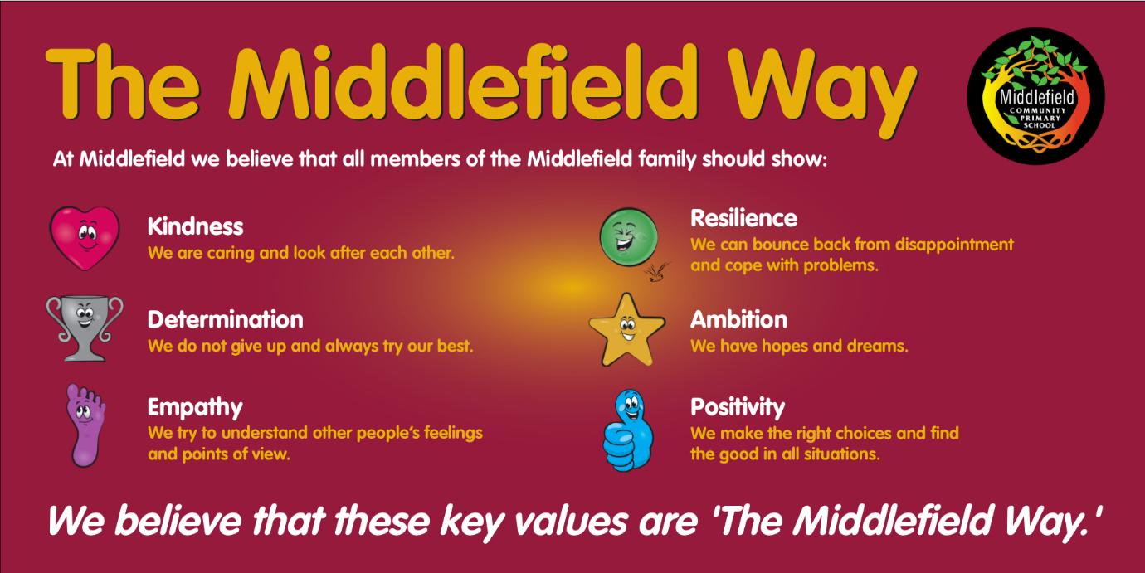

Behaviour expectations:
To show the Middlefield Way…
1. We speak using a calm voice.
2. We help each other to be safe.
3. We help each other to learn.
4. We respect each other and our environment.
5. We follow instructions.
All members of the school community share responsibility for promoting positive behaviour. Staff will apply this policy consistently and fairly, pupils are expected to follow the Middlefield Way, and parents/carers are expected to work in partnership with the school to support high standards of behaviour.

Classroom sanctions
If you choose not to follow our expectations these consequences will happen every time …
1. A member of staff will tell you to stop, they will tell you once, and they will not engage in conversation or stop the lesson to repeat the warning.
2. Your name will be written on the board, once again teachers will not stop the lesson or repeat warnings. The lesson must continue as uninterrupted as possible.
3. A tick will be put next to your name and you will receive a negative behaviour point.
4. If you continue this behaviour, further ticks, and therefore negative points will be added.
5. Two ticks in the same session (AM/PM) means you will lose part of your lunch break in Reflection Club, where you will complete a reflective activity.
6. Your parents/carers will be alerted via Class Charts when you receive negative behaviour points. Persistent patterns of negative behaviour may result in appropriate intervention and parents/carers being called.
Negative behaviour on the playground will result in a negative behaviour point and appropriate conflict resolution by members of staff on duty.

Reflection Club
Reflection Club provides pupils with an opportunity to reflect upon their choices and consider how they can make positive behaviour decisions in the future.
During Reflection Club, pupils will:
- Discuss the incident with a member of staff.
- Complete restorative conversations.
- Reflect on how their actions affected others.
- Identify strategies to support improved behaviour.
Reflection Club will be supervised by pastoral staff and SLT. It will be used consistently and proportionately to support pupils in developing self-regulation and responsibility for their actions.
Rewards
Children will be rewarded with positive behaviour points (on Class Charts) linked to our Middlefield Way values. Points can be redeemed on Class Charts’ online store. Children will be able to purchase small, instant prizes or can save up for larger prize rewards. Consistent positive behaviour will also be celebrated via notifications/badges.
Serious Incidents
Sometimes an incident happens which overrides the above. This will be an incident of serious misbehaviour…
• Aggressive or violent behaviour towards pupils and or staff
• Child-on-child abuse, including sexual harassment, sexual violence, harmful sexual behaviour and online abuse.
• Incidents which are deemed to put others safety at risk
• Bullying, racist, sexist or homophobic comments
For these incidents the HT or DHT should be informed immediately. These incidents will be recorded on CPOMS. Parents will be informed as soon as possible. 5 negative behaviour points will be applied for each incident.
When some help is needed
We acknowledge that some children may have particular emotional, social, medical or learning problems which may mean that they will sometimes display challenging behaviour. In these cases, we will aim to work with the child, parent / carer and professionals to find out what the problem is, try to understand it and put together a plan with targets to address the additional need/s. This will be done by the SLT and class teacher and whenever possible parents/carers will be part of the process. We will always try to ensure parents / carers are fully informed. We also realise that, despite the support and help offered in school, sometimes we need to ask for outside agencies to become involved, like the Educational Psychology service or health.
Suspensions
The Governing Body of Middlefield School will follow the Department for Education and Local Authority guidelines.
In this school, suspension is always used as a last resort, after all other strategies have failed. It is applied in cases where, by allowing a child to remain in school, we would be placing other pupils /staff at risk or by allowing a child to remain in school it would be detrimental to the education or welfare of other pupils/ staff.
Whilst a pupil is suspension they are not allowed onto school premises.
The head teacher, or senior leader, will contact the parent as soon as possible. A letter will be sent home, setting out the reason why the suspension has taken place and the school will inform the Local Authority.
Please see ‘School Exclusions: Advice to Parents’ for further information
Bullying
Bullying is deliberately hurtful behaviour that is repeated over a period of time.
We endeavour to prevent bullying by implementing this policy consistently throughout the school. Bullying will always be taken seriously and dealt with immediately.
Bullying is the wilful and repeated desire to hurt, threaten or frighten someone. ‘Falling out’ with a friend is not bullying.
A bully has to have some kind of power over the victim and use it in an abusive and unkind way over a period of time. An argument between two equal partners is not bullying.
All confirmed incidents of bullying will be recorded and monitored; parents will be informed.
Please see school’s ‘Anti-bullying policy’ for further information.

Equality and Protected Characteristics
The school is committed to promoting equality, diversity and inclusion. Discriminatory language, behaviour or incidents directed towards an individual or group on the basis of a protected characteristic will not be tolerated.
This includes disability, race, religion or belief, sex, sexual orientation and gender reassignment.
All incidents will be investigated thoroughly, recorded appropriately and dealt with in line with this policy and safeguarding procedures.
The use of Reasonable Force
Guidance from the DfE states…
• The term reasonable force covers the broad range of actions used by most teachers at some point in their career that involves a degree of physical contact with pupils
• Force is usually used to control or restrain. This can range from guiding a pupil by the arm to more extreme circumstances such as breaking up a fight or when a student needs to be restrained to prevent violence or injury
• Control means either passive physical contact, such as standing between pupils or blocking a pupil’s path. Restraint means physically holding back. This is typically used in more extreme circumstances i.e. when pupils are fighting
• ‘Reasonable’ means using no more force than necessary
• Staff must always try to avoid acting in a way that might cause injury, but in extreme cases it may not always be possible
• Staff should avoid physical contact when dealing with incidents where possible
We will always tell parents immediately if force has been used in an incident
The staff to which this power applies…
1. A teacher who is working at our school
2. Any other person the HT has authorised for example; Support staff, dinner staff

Behaviour Outside of School
The school may apply sanctions for behaviour that takes place outside the school premises when it is reasonable to do so. This may include behaviour which:
- Could have repercussions for the orderly running of the school.
- Poses a threat to another pupil, member of staff or member of the public.
- Could adversely affect the reputation of the school.
- Involves online behaviour or social media activity connected to the school community.
Where appropriate, incidents occurring outside school will be investigated and managed in partnership with parents, external agencies and, where necessary, the police.

